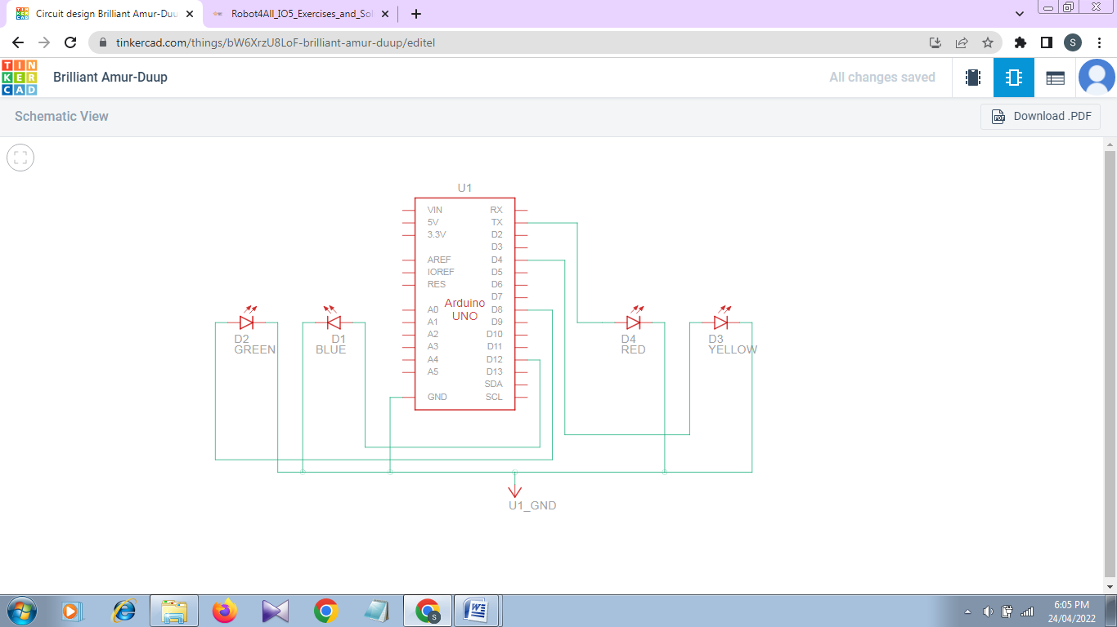**Schematic View:**

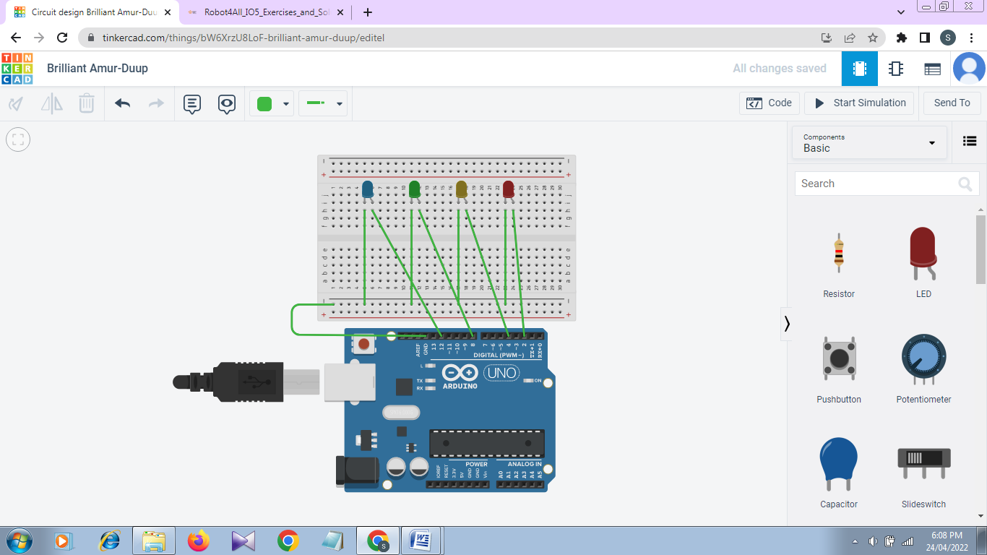**Circuit View:**

**Code:**

int blue=12;

int green=8;

int yellow=4;

int red=2;

int ButtonState;

int InputByte;

void setup()

{

pinMode(blue, OUTPUT);

pinMode(green, OUTPUT);

pinMode(yellow, OUTPUT);

pinMode(red, OUTPUT);

Serial.begin(9600);

}

void loop()

{

ButtonState=digitalRead(2);

Serial.println(ButtonState);

delay(1000);

if(Serial.available())

{

InputByte=Serial.read();

if(InputByte=='B')

{

digitalWrite(red,LOW);

delay(3);

digitalWrite(blue,HIGH);

digitalWrite(green,LOW);

digitalWrite(yellow,LOW);

delay(3);

}

else if(InputByte=='G')

{

digitalWrite(red,LOW);

digitalWrite(green,HIGH);

digitalWrite(blue,LOW);

digitalWrite(yellow,LOW);

delay(3);

}

else if(InputByte=='Y')

{

digitalWrite(red,LOW);

digitalWrite(yellow,HIGH);

digitalWrite(green,LOW);

digitalWrite(blue,LOW);

delay(3);

}

else if(InputByte=='R')

{

digitalWrite(red,HIGH);

digitalWrite(green,LOW);

digitalWrite(yellow,LOW);

digitalWrite(blue,LOW);

delay(3);

}

else

{

digitalWrite(red,LOW);

digitalWrite(green,LOW);

digitalWrite(yellow,LOW);

digitalWrite(blue,LOW);

delay(10);

}

}

}